Docker and Rails: Running Ruby on Rails with Docker

Before start dockerization must watch this tutorial for basic understanding of docker
Docker Tutorial for Beginners

When working with large distributed teams, you often run into the issue of something working on one computer but not others. When building and running applications, each developer has a slightly different development environment. For example, one developer may use a Windows PC to build and run an application that was developed on a Mac. Apart from the differences in the command line, the developer trying to run the applications may not have the required dependencies installed, and the process of finding and installing the correct versions of the dependencies slows development. This is where containerization tools, like Docker, can help.
Docker lets you package applications with all their dependencies into a single image that can be distributed across teams. By doing so, you only need to install Docker in your development environment to run the application.
If you’re building a Ruby on Rails application, Docker helps to ensure that everyone on the team is running the same version of Ruby and other dependencies your application needs.
In this tutorial, you’ll learn how to run a Ruby on Rails application inside a Docker container and what some best practices are for doing so.

Docker Image:
Before you begin this tutorial, you’ll need the following prerequisites:
- Docker: should be installed on your local machine. Make sure you install the correct version for your operating system.
- Docker Compose: is needed to manage multiple containers at once. Instructions to install it are available on the Docker docs.
- Ruby on Rails: needs to be installed if you’re creating a new Ruby application.
- After successfully install docker & docker-compose,now you have to signup or login on docker desktop by clicking sign in button & on terminal by running these commands
$ gpg –generate-key
$ pass init <generated gpg-id public key>
$ sudo docker login

Writing the Dockerfile:
Open up the docker-rails folder in Visual Studio Code or any other IDE, and create a new file called Dockerfile in the root directory. In the Dockerfile, paste in the following code:
FROM ruby:2.7.2-alpine

RUN mkdir /home/app
WORKDIR /home/app
COPY ./ ./

RUN apk add --no-cache build-base nodejs tzdata postgresql-client postgresql-dev
RUN bundle install

COPY entrypoint.sh /usr/bin/entrypoint.sh
RUN chmod +x /usr/bin/entrypoint.sh
ENTRYPOINT ["entrypoint.sh"]
CMD ["rails", "server", "-b", "0.0.0.0"]

Take a look at what each line of code is doing:
- FROM: instructs Docker to use a specified parent image as a starting point when building the image. Since you’re building a Ruby application, you’re using the official Ruby image, which has Ruby preinstalled as your base (Alpine images use apk instead of apt-get as a package manager).
- WORKDIR: sets the specified directory as the working directory inside the Docker image. Any further commands Run in the Dockerfile will be run in the context of this directory.
- COPY: is used to copy files from the host machine into the Docker image. The syntax for this is COPY <source> <destination>.. The period (.) refers to the current directory.
- Run: RUN command install some necessary packages for your Rails app since the Alpine image is mostly bare.
- CMD: is the main entry point to your Docker image. It’s the command that is run whenever a container is created.

Modifying Your Database Settings:
Before you write the docker-compose file, you need to modify your application to connect to the database. In the config directory, modify the database.yml file with the following:Set the username, password, and host.
username: postgres
password: postgres
host: db

OR
Set username, password, and host are set from environment variables.
username: <%= ENV['POSTGRES_USER'] %>
password: <%= ENV['POSTGRES_PASSWD'] %>
host: <%= ENV['POSTGRES_HOST'] %>

Rails expects a PostgreSQL database to be running on localhost, but that isn’t the case since you’re running inside of a container. A solution to this is to start a separate PostgreSQL Docker container and point your application to it. Thankfully, Docker has a tool for setting up and managing multiple containers: Docker Compose. Docker Compose is configured with a YAML file, which must be named docker-compose.yml.

Writing the docker-compose.yaml File:
Create a file called docker-compose.yaml in the root directory and paste in the following code:

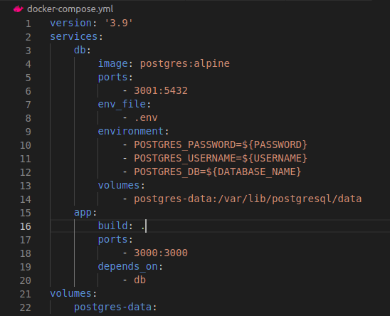

version: '3.9'
services:
db:
image: postgres:alpine
ports:
- 3001:5432
env_file:
- .env
environment:
- POSTGRES_PASSWORD=${PASSWORD}
- POSTGRES_USERNAME=${USERNAME}
- POSTGRES_DB=${DATABASE_NAME}
volumes:
- postgres-data:/var/lib/postgresql/data
app:
build: .
ports:
- 3000:3000
depends_on:
- db
volumes:
postgres-data:

Here, you define the
version as 3.9; then, you specify two services. The db & app service, db service uses the PostgreSQL image, this is an image that gets pulled down from Docker Hub,and then, define the ports (host port:Container port) this is called port mapping .env_file define the .env file path, then set environment variables for the POSTGRES_PASSWD, POSTGRES_USER, and POSTGRES_DB. The app service, uses the build: . To build the image and After that, you expose port 3000 and depends_on: db

Writing the .env File:
Create a file called .env in the root directory and paste in the following code:
PASSWORD=postgres
USERNAME=postgres
DATABASE_NAME=ecomerece_development

Copy these PASSWORD,USERNAME AND DATABASE_NAME from database.yml file.

Writing the entrypoint.sh File:
Create a file called entrypoint.sh in the root directory and paste in the following code:
#!/bin/sh
set -e
rm -f /home/app/tmp/pids/server.pid
RAILS_ENV=development rails db:migrate && rails db:seed
exec "$@"

To run docker local server remove the pid server and then write the migration and seed command.

Stop POSTGRES Locally:
After writing all above files, check your local postgres
status by using this command
systemctl status postgresql

if postgres server is running locally then you have to stop
it by using this command
systemctl stop postgresql

To verify run this command again
systemctl status postgresql

Start the container:
Now,build & start the containers by running docker-compose up:
sudo docker compose up --build

Navigate to http://localhost:3000. And you should be greeted with the Rails app:

Creating a repository on Docker Hub
Now that we have created our Dockerfile let’s create a repository within Docker before we push it to an online repository. If you’re well-acquainted with the way Github works, then Docker hub isn’t that different from it.
So head over to Docker Hub and register an account. After signup, click the Repositories tab in the navbar, you’ll see a form like the one shown below:
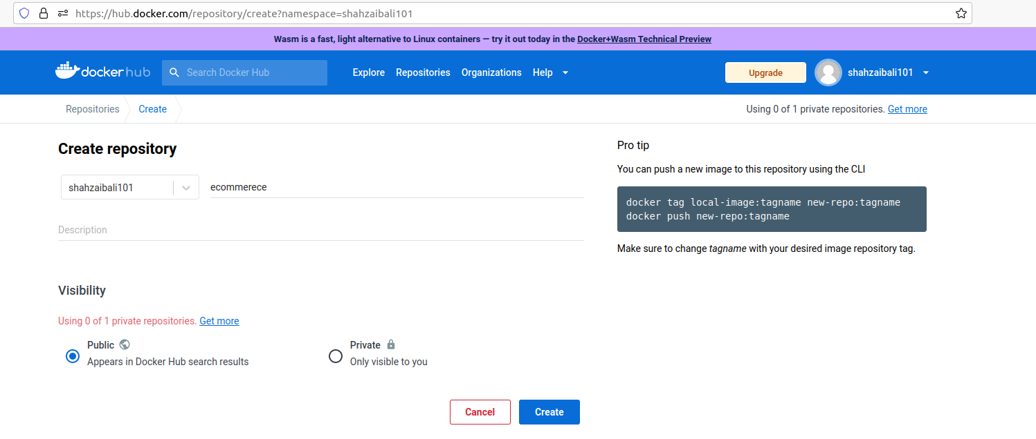
Create a repository. Now that our repository is set, let’s create an image from Docker and push it to the repository we created earlier.

You can push a new image to this repository using the CLI
docker tag local-image:tagname new-repo:tagname
docker push new-repo:tagname

docker push syednouman/instagram-clone:tagname

e.g
run this command to see your local-image
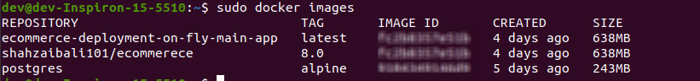
push image to the repository example

If you face an issue while installation :error

The issue you are facing is due to the missing Docker repository on your system, which you can resolve by following a part of Docker Engine's documentation as follows:
sudo apt install -y ca-certificates curl gnupg lsb-release

sudo mkdir -p /etc/apt/keyrings

curl -fsSL https://download.docker.com/linux/ubuntu/gpg | sudo gpg --dearmor -o /etc/apt/keyrings/docker.gpg

echo "deb [arch=$(dpkg --print-architecture) signed-by=/etc/apt/keyrings/docker.gpg] https://download.docker.com/linux/ubuntu $(lsb_release -cs) stable" | sudo tee /etc/apt/sources.list.d/docker.list > /dev/null

sudo apt update -y

After that, you can go on with the installation of Docker Desktop:
By command:
sudo apt install ./docker-desktop-<version>-<arch>.deb

Or By clicking on downloaded docker-desktop deb file.

P.S. Don't get panic if you see the error below at the end of the installation process. Just ignore it and you'll be fine ;)
Download is performed unsandboxed as root as file docker-desktop-
<version>-<arch>.deb couldn't be accessed by user '_apt'. -
pkgAcquire::Run (13: Permission denied)

Verify your installation:
by running this command.
sudo docker run hello-world
Hello from Docker!This message shows that your installation appears to be working correctly.
If you got an authentication required error then restart your system.

Some basics Docker Commands
- # Starting up your project
sudo docker compose up –build
- # Shutting down project
sudo docker compose down
- # Shutting down and clearing database
sudo docker compose down –volumes
- # docker help
docker –help

